STATE OF WASHINGTON
DEPARTMENT OF HEALTH
Early Hearing Detection, Diagnosis, and Intervention Program
1610 N.E. 150thStreet ∙ Shoreline, Washington 98155
Phone 206-418-5613 Toll Free 1-888-WAEHDDI (1-888-923-4334) Fax 206-364-0074

Resource Referral Form for Children who are Deaf or Hard of Hearing

How to complete this form:
- Discuss the resources on page 2 with the child’s parent or guardian.
- Select which resources they would like to be referred to.
- Complete the contact information section and have the child’s parent or guardian sign the authorization below.
- Fax completed forms to the EHDDI program at (206) 364-0074. The EHDDI program will forward the referral to the organization(s) selected and mail the family a resource notebook, if requested.

Child’s Name: |  | DOB:
Parent/Guardian Name:

Mailing Address:

City: | State: | Zip:
Phone Number: | Email:
Primary Language Spoken:

Referring Provider: | Clinic:

By signing below, I authorize the Washington State Department of Health Early Hearing Detection, Diagnosis, and Intervention (EHDDI) program to share my contact information and my child’s name and date of birth with the organizations selected on the next page for the purpose of obtaining resources or services.

Parent/Guardian Signature:_____________________________________ Date:_______________

Relationship to Child: _____________________________________________________________

Please check the box next to the resources you would like to receive.

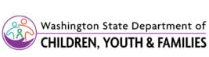 | ☐ | Early Support for Infants and Toddlers (ESIT Program) – Provides early intervention services for eligible children (ages birth to 3). Family resources coordination, developmental screening, and evaluations to determine eligibility are provided at no cost to families. Families will be contacted by their local Family Resources Coordinator (FRC).
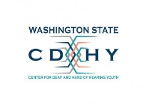 | ☐ | Center for Deafness and Hard of Hearing Youth (CDHY) – Offers statewide services for children who are deaf and hard of hearing and their families, teachers of the deaf, school districts, educators serving the deaf, and educational interpreters.
 |  | Telephone Number: 855-342-1672 | Fax Number: 360-696-6291
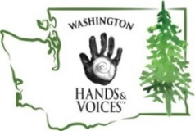 | ☐ | Washington Hands & Voices – Guide By Your Side™ (GBYS) – Provides unbiased emotional support and resources by trained Parent Guides who are parents of children who are deaf or hard of hearing. GBYS services are provided at no cost to families.
 |  | Telephone Number: 425-268-7087 | Fax Number: 360-715-9970
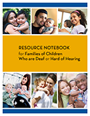 | ☐ | Resource Notebook for Families of Children Who are Deaf or Hard of Hearing – A free notebook that includes stories from other families, information about hearing and assistive technology, communication options, and early intervention services.

If you have any questions, please contact us at (206) 418-5613.

Thank you for your time,
Washington State Early Hearing Detection, Diagnosis and Intervention (EHDDI) Program

DOH 344-073 Mar 2021

